First meeting in Sweden - Personal feedback - German point of view
According to the COMENIUS Handbook
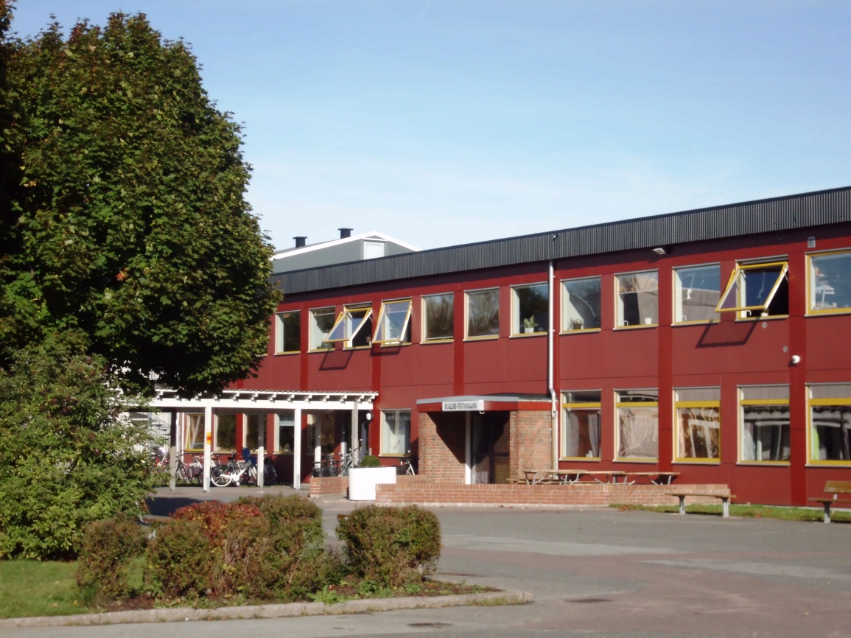
Yes, indeed, the plans for our first meeting were fulfilled. It was great that we could finally meet and I am very thankful for the invitation of the Swedish school Brattebergsskolan in Öckerö.
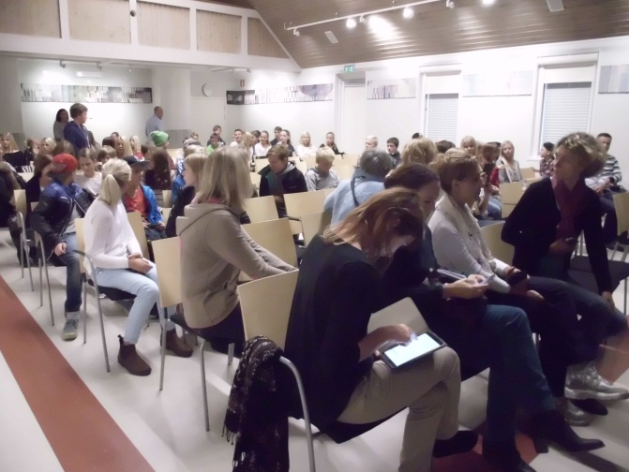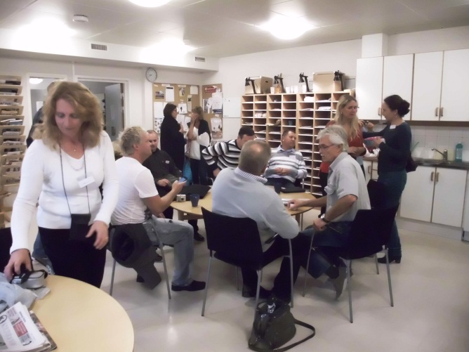
Planning the first meeting is a real challenge, but our stay was organized very well, accommodation as well as our visits at school or the trip to Gothenburg : not only sightseeing with lovely pupils as our guides, but also a guided tour through an exhibition about the Romanies and their history in the City Museum of Gothenburg.
The insight into local and regional culture was really enjoyable, colleagues at school, the headmaster and the representatives of the municipality were very helpful, we enjoyed their support, their hospitality and the mutual exchange.
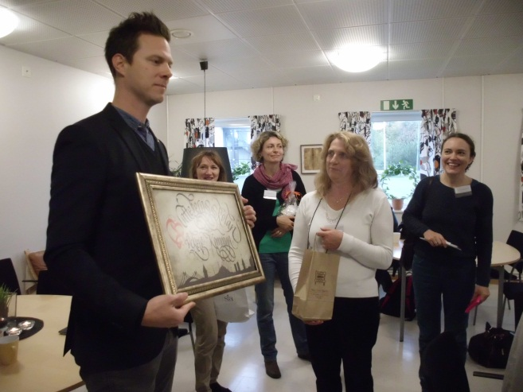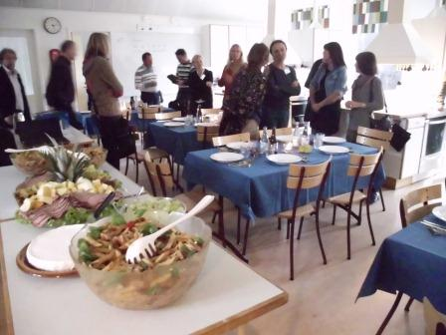
We had a lot of interesting discussions about our different school systems and various other socio-cultural topics, covering all generations and the situation they live in. All people we met spoke English well, but this is no surprise to me, as TV shows original versions of films, oral comprehension reaches a high level.
Also the technological standard is high – with tablets and Wlan at school for each pupil – to be used at any time, if necessary. In my opinion there is also a more tolerant atmosphere and a higher acceptancy of pupils´ interests, there are less rules and regulations than at my school in Germany, especially as regards the use of headphones, mobile phones or tablets. But in spite of all freedom: safety restrictions are always respected and play a big role. Teachers have a work-station at school where they really can work – quite surprising to a German teacher like me.
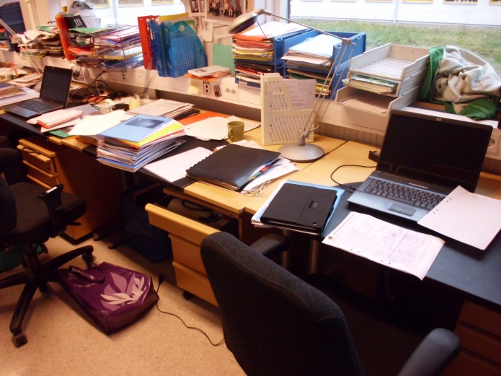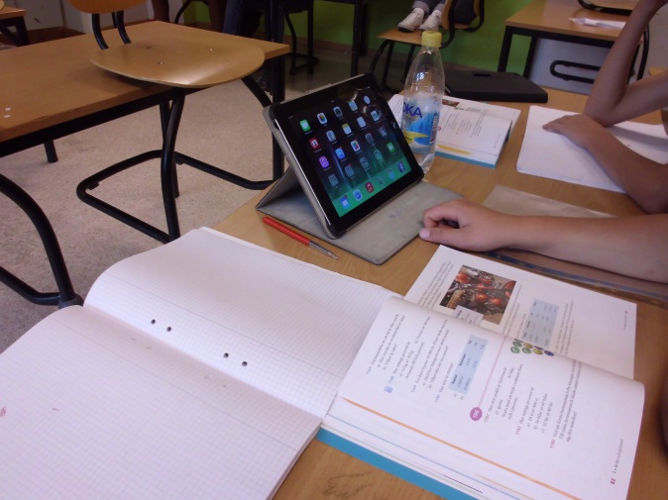

I consider the aims of our first meeting to be fulfilled and the exchange of our first introductory material was successful, even if we have to take into account the various regulations about publishing material online, especially when pupils are involved. At the present state of our project work we see no reason to change our plans, the work schedule until December and the second meeting in Italy was discussed in detail, plans for the period until the third meeting in France précised, according to our work plan.
We had decided not to take pupils to our first meeting. Countries in Southern Europe have started school only in September, so it would have been too short of notice. And: we also had to check the etwinning Twinspace as the main platform where we will upload and exchange work results, we discussed the folder structure and uploaded first content. Two work sessions were necessary to make everybody familiar with its use, and now each participating teacher is able to invite his or her pupils.
As the autumn holidays in Lower Saxony have just ended, there has been only an informal exchange of information with my pupils, they are eager to continue their work, as they have some experience with doing project work and sharing content on the etwinning Twinspace, they simply want to continue. By starting a new project, not only etwinning, but even COMENIUS, their motivation is held high and they choose from a variety of topics: either following their own ideas or preparing contributions to the general work plan of our project. Typical question: Is there anything to be done for our project? And the prospect of maybe having the chance to take part in a COMENIUS meeting make some of my pupils work very hard, in their free time and in an extra project lesson at school, not only in the classroom lessons which are intended for project work.
Socializing among us took place in the evenings. It was a great that we could all stay together in one hostel. Yes, I knew some members of our teachers´ group beforehand, but not so many of the others did, so I think I can say that we all met as colleagues but we said goodbye as friends, and we all look forward to our next meeting. A draft plan has already been sent via email and we continue sharing news in our closed Facebook-group – teachers only – up to now.

