VISIT IN GERMANY – FEEDBACK FROM FRANCE
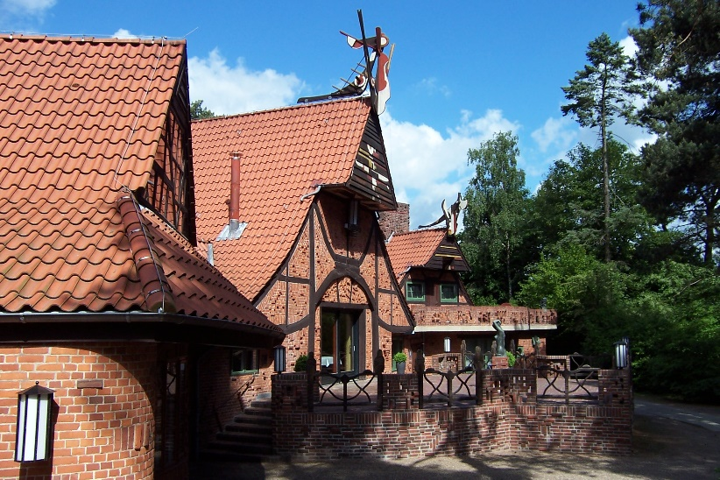
December couldn’t have a better beginning, as we spent a week in Worpswede, Germany. Most of us flew to Bremen, where we were met by our busy but nonetheless warm, and friendly German counterpart. We then made our way to the station, from there a bus would take us to Worpswede. Right in front of the station, there was a small market which was a very nice first insight of the German culture, the outside temperature reaching -4°C, the lightings, the music played in the background, the sweets and the Christmas cookies all contributed to the creation of a magic atmosphere. Some stalls were full of pretzels: no doubt we are really in Germany!

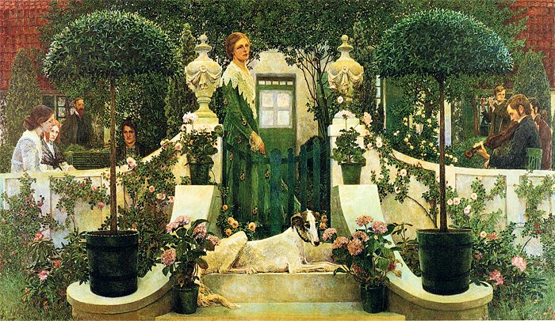
A 1 hour-ride on a bus took us right in front of our hotel, a very nice and cosy hotel. It felt as if its owner opened the doors of her own house to us. We knew straight away that she would try her best to make our stay more than enjoyable. We couldn’t help noticing that a great number of nice paintings were displayed on the walls, just as if we were in an art gallery. And we were right: the hotel was actually a gallery. The whole town is a gallery on its own. A short walk around confirmed this idea. The centre is quite unusual since this bucolic town only has a few shops, but abounds with art galleries. A visit to the museum the day after our arrival will explain how Worspwede has grown over the years to become an artists’ colony, counting among its inhabitants some famous painters such as Otto Modersohn or even Paula Becker but also attracted poets and writers.
First day at school! Yes, but a German one. The whole school seemed to have taken part to the project. There were COMENIUS signs everywhere, flags on the walls as well as descriptions of our countries nicely prepared and illustrated by the students. All German pupils gathered in a reception room. We could see instruments set on the stage, the headmasters gave us a welcome speech in French, English and German, and then introduced the band behind her. They were all students from the high school and I have to say that their performance was outstanding. Is there any better and friendlier welcome than this one? Here again: the magic happened. We all had the same feeling when we arrived at the town hall where the mayors of Worpswede as well as the mayor of the neighbouring town Grasberg awaited us.
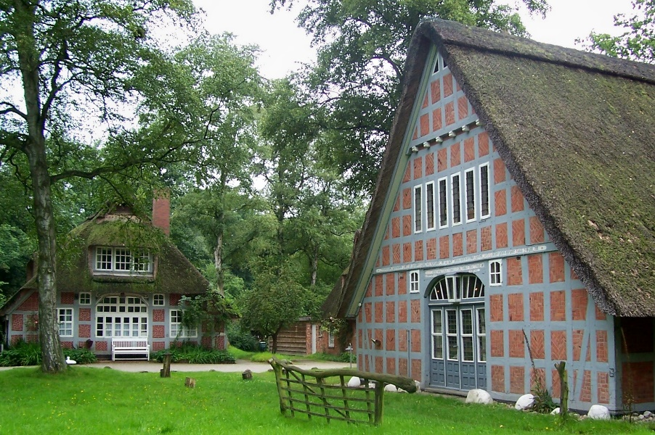

Grasberg is the hometown of the Findorffhof Museum, a museum built as a spacious courtyard from old half-timbered buildings. It has a large number of farm equipment that reflects the arduous life of yesteryear. The house has been kept as it was then, offering us the opportunity to see how the inhabitants dealt with the harsh weather conditions (which we could figure as it was actually very cold). Also, on the first floor, there were women working on a traditional wooden handloom. The visit ended with a nice cup of tea, chocolates and the traditional regional cake, called Butterkuchen, (a butter cake sprinkled with sugar), very tasty, I have to admit. One should mention again the sense of hospitality here, as our guide was the mayor of Grasberg herself.
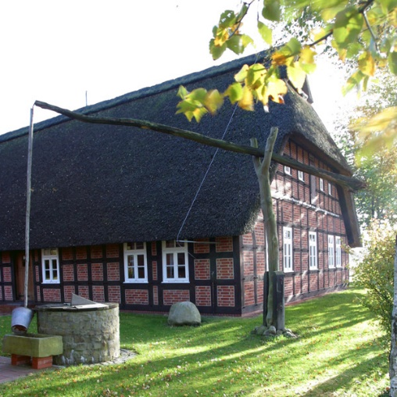
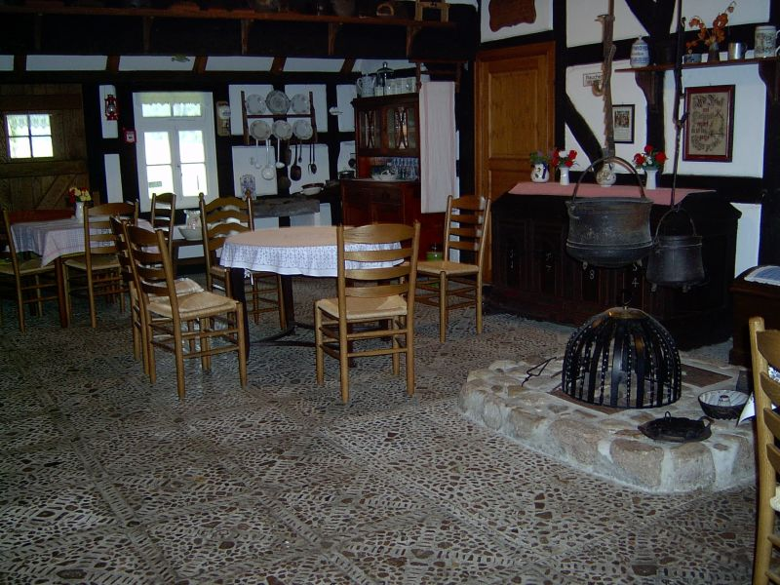

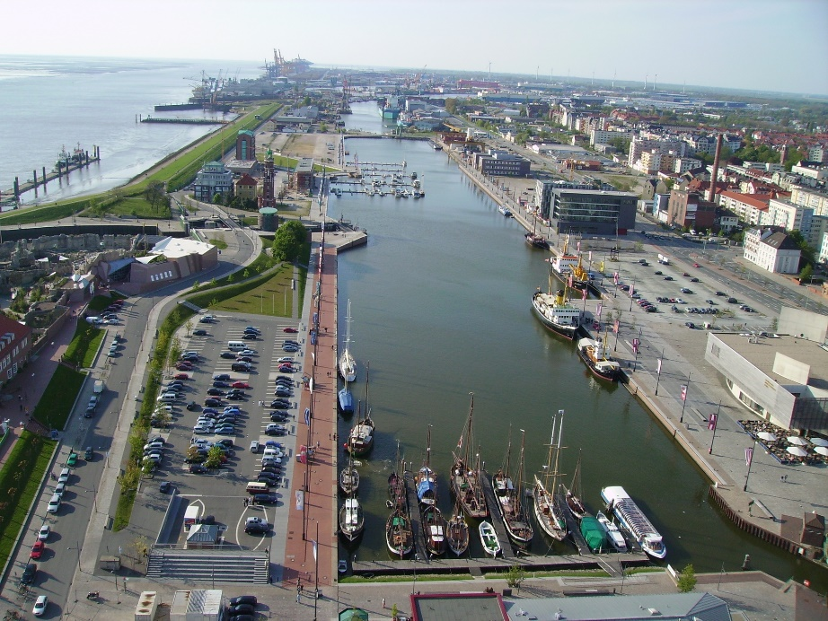
Back at the high school, we were given a presentation on how the German students are prepared for the job market through internships and what role the school plays in finding the companies. We were then split up in little groups of 5 and were able to visit the companies where the students were trained. Ours was a firm manufacturing elevators which will then be used by Airbus to build the gigantic A380, the trainees here were working on 3D projects. The whole day was dedicated to our topic related to the Economy in our countries, with presentations and discussions. However, one must eat, and our hosts again organised a really nice restaurant for us in the outskirts of Worpswede, Schameika.

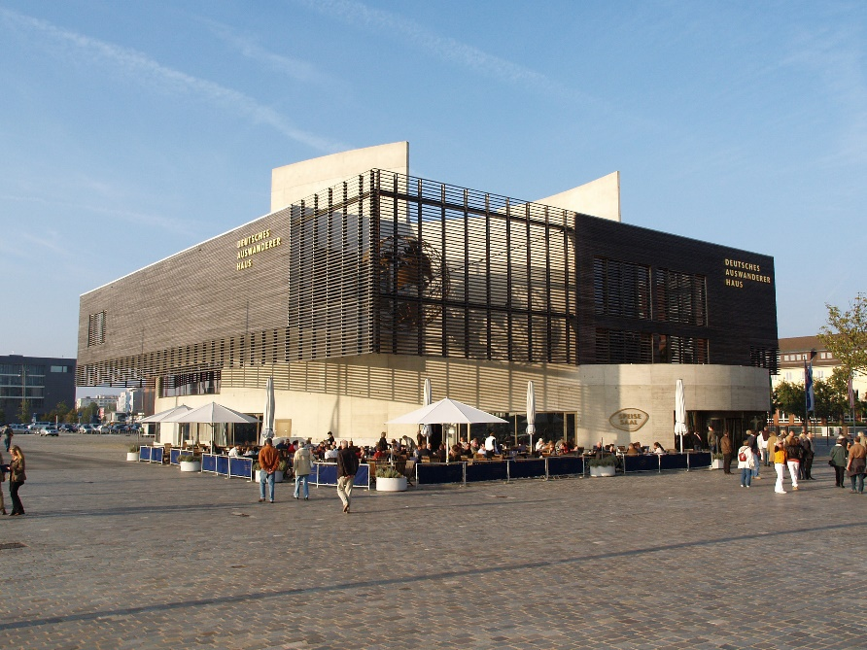
The next day, we went to Bremerhaven, the Bremen’s Harbour, a door to the world. The city has long served as a trade port and is now one of the most important German ports, playing a crucial role in Germany’s trade. The port was filled with cargo ships ready to send German made products to the world. Bremerhaven does not only send and receive goods but also people. Ports have always been crossroads to the world, and Bremerhaven is no exception.
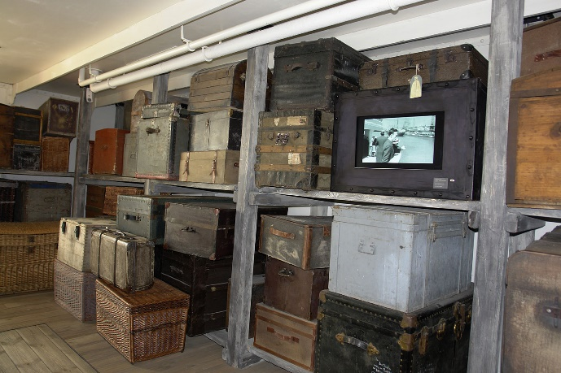
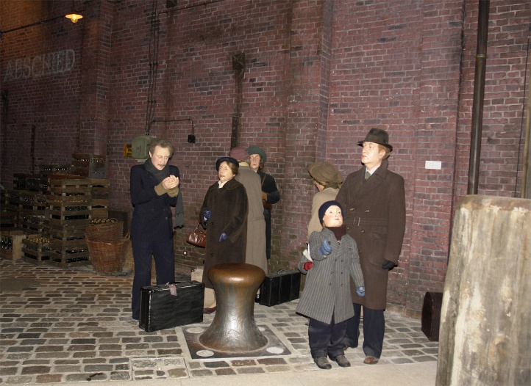
The Auswandererhaus, the German emigration centre recounts and explains the migration flows to and from Germany. This museum received the European Museum of the Year Award in 2007, and to be honest this award is highly deserved. The visitor truly follows the steps of a migrant. When you enter the museum, you face the mock-up of a ship, with mannequins dressed exactly as they would have been at the time. We felt the way the museum illustrated the emigration/ immigration experience, from the actual stories of people, really brought the narrative to life. We could listen to the reports of a migrant from his life in Germany, his aspirations to the outcome of his migration. We can even board the ship, and see the living conditions on-board the ship taking the Germans to America, Australia or Argentina.

After such an informative and quite emotional morning we completed the day ice skating. It was nice to see experienced ice skaters and novice ones on the rink having fun together. We ended the day around a nice dinner, we were also able to play Kegeln, a German version of bowling.
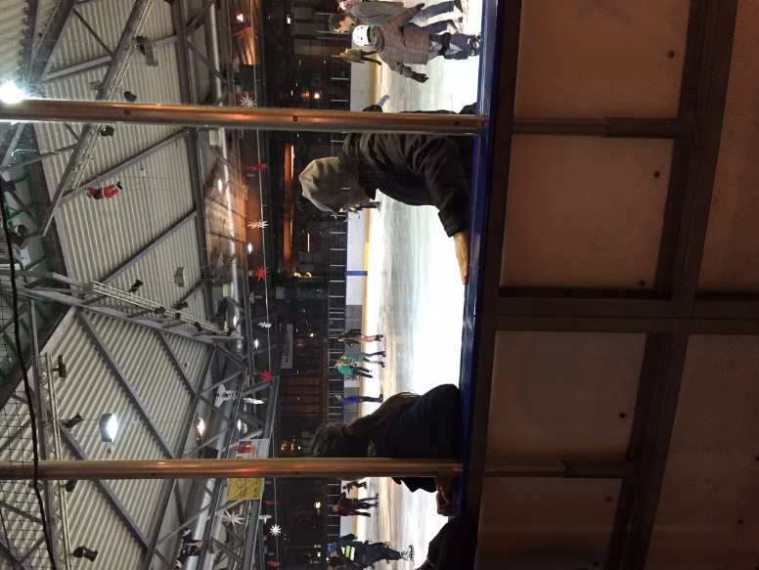
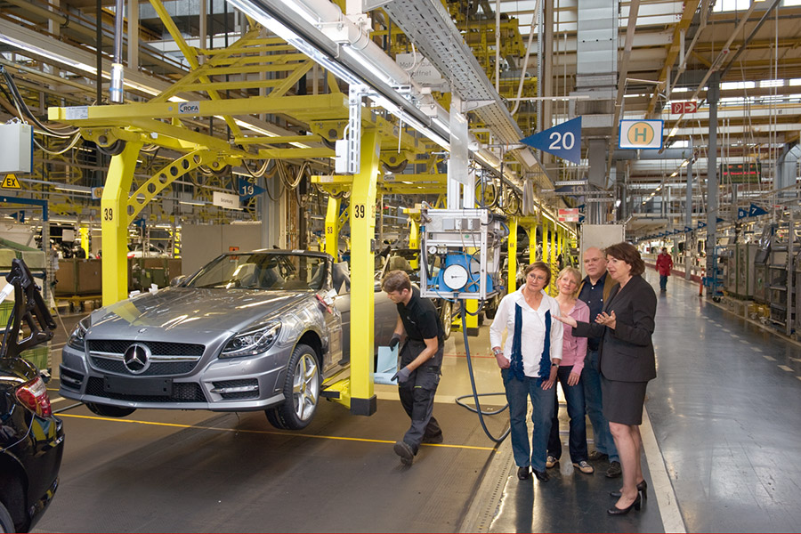
Another highlight of our week in Germany was the visit of the Mercedes premises. The property was that huge that we had to take a bus to go from one building to the other. Mercedes is obviously known worldwide but not many of us had the chance to visit the factories creating these famous luxury cars. We were impressed by the automation in this factory. Some teachers even had the possibility to board a Mercedes car and go on a tour on a specially designed circuit.

Back at the school, we were offered a party attended by the teachers as well as all the German pupils. This is a perfect way to bring people together but unfortunately it was also the time for us to say goodbye to the German students and teachers who had taken care of us for a week. However our mission was not over yet. We still had to discuss some crucial points. The students dealt with the topic of unemployment as well as the economic situations in their respective countries while the teachers were preparing the next stays abroad. Then came the moment when our students presented a national company.
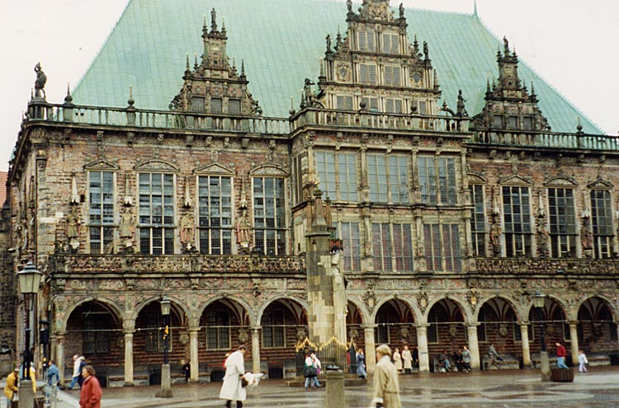
The whole afternoon was dedicated to the visit of Bremen, the second largest city in Northern Germany. The architecture was stunning, a mixture of Gothic and Renaissance style. The presence of a Christmas market in the centre added magic to an atmosphere which was already a winter wonderland. Our German hosts also took us to another market, along the river, which stood out. It was a medieval market.
Back into the centre, we were fortunate enough to attend a sound and light show displayed on the cathedral. Was it another German Christmas magic effect on our way to the Ratskeller? A nice Bavarian restaurant where the personnel attended us in their traditional Bavarian outfit, offering us Bavarian size drinks. Not only could we enjoy a galore of typical German food, but also a really festive atmosphere. A festive but nonetheless strange atmosphere as we were about to thank our hosts for such a nice stay.

A busy week, came to an end, we all had to go back home but we all enjoyed a stay that was definitely not ordinary. It was replete with culture, fun, and exchanges, all on a Christmas atmosphere background. Thank you Germany.

Dominique Dejean

